BANDPASS FILTER

CONTENTS:

1.Objectives

2.Introduction

3. Theory

4.Apparatus Required

5.Circuit Diagram

6.Experimental Data

7.Graphical Analysis

8. Cost Analysis

9.Discussion

10.Application

11.Conclusion

12.References

OBJECTIVES:

1.To construct a Bandpass filter.

2.To set lower cut-off frequency at 4kHz.

3.To set higher cut-off frequency at 8kHz.

Introduction:

In this experiment,we are going to be acquainted with the bandpass filter and going to build a proper circuit that can operate as a bandpassfilter.Abandpass filter has two particular cut-off frequency.Any input frequency outside this band is attenuated.Here we are going to fix the cut-off frequencies at 4kHz to 10kHz using 2nd order high pass filter and 2nd order low pass filter.

THEORY:

A filter circuit is a circuit that removes unwanted frequency components from a signal. Filters are classified into active and passive filter. Active filters are constructed with transistors or OP-AMP in addition to resistor and capacitor. The most commonly used active filters are 5 types. Bandpass filter is one of them.A bandpass filter is an

3

electronic device or circuit that allow signals between two specific frequencies to pass,but that discriminates against signals at other frequencies.If the lower cut-off frequency is f1 and higher cut-off frequency is f2,then the range between f1 and f2 is called the filter pass band.

F2= 1/(2π)

If R1=R2 and C1=C2 then,

F2= 1/2πRC

Bandpass filter is of two types-wide bandpass filter and narrow bandpassfilter.Here the quality factor,Q=fc /(fH-fL).

fc=center frequency

If Q<10,its wide bandpass.If Q>10,its narrow bandpass.Bandpass filter is constructed with a high pass filter and a low pass filter.We are going to use here the 2nd order version of them.So,we are going to use 2 capacitors and 2 resistors for each filter circuit.

APPARATUS REQUIRED:

1.Breadboard

2.OP-AMP(IC-741)

3.Resistors(1KΩ,2KΩ,10KΩ)

4.Capacitors(0.04 µF,0.01 µF)

5.Function Generator

6.DC Power Supply

7.Connecting wires

CIRCUIT DIAGRAM:

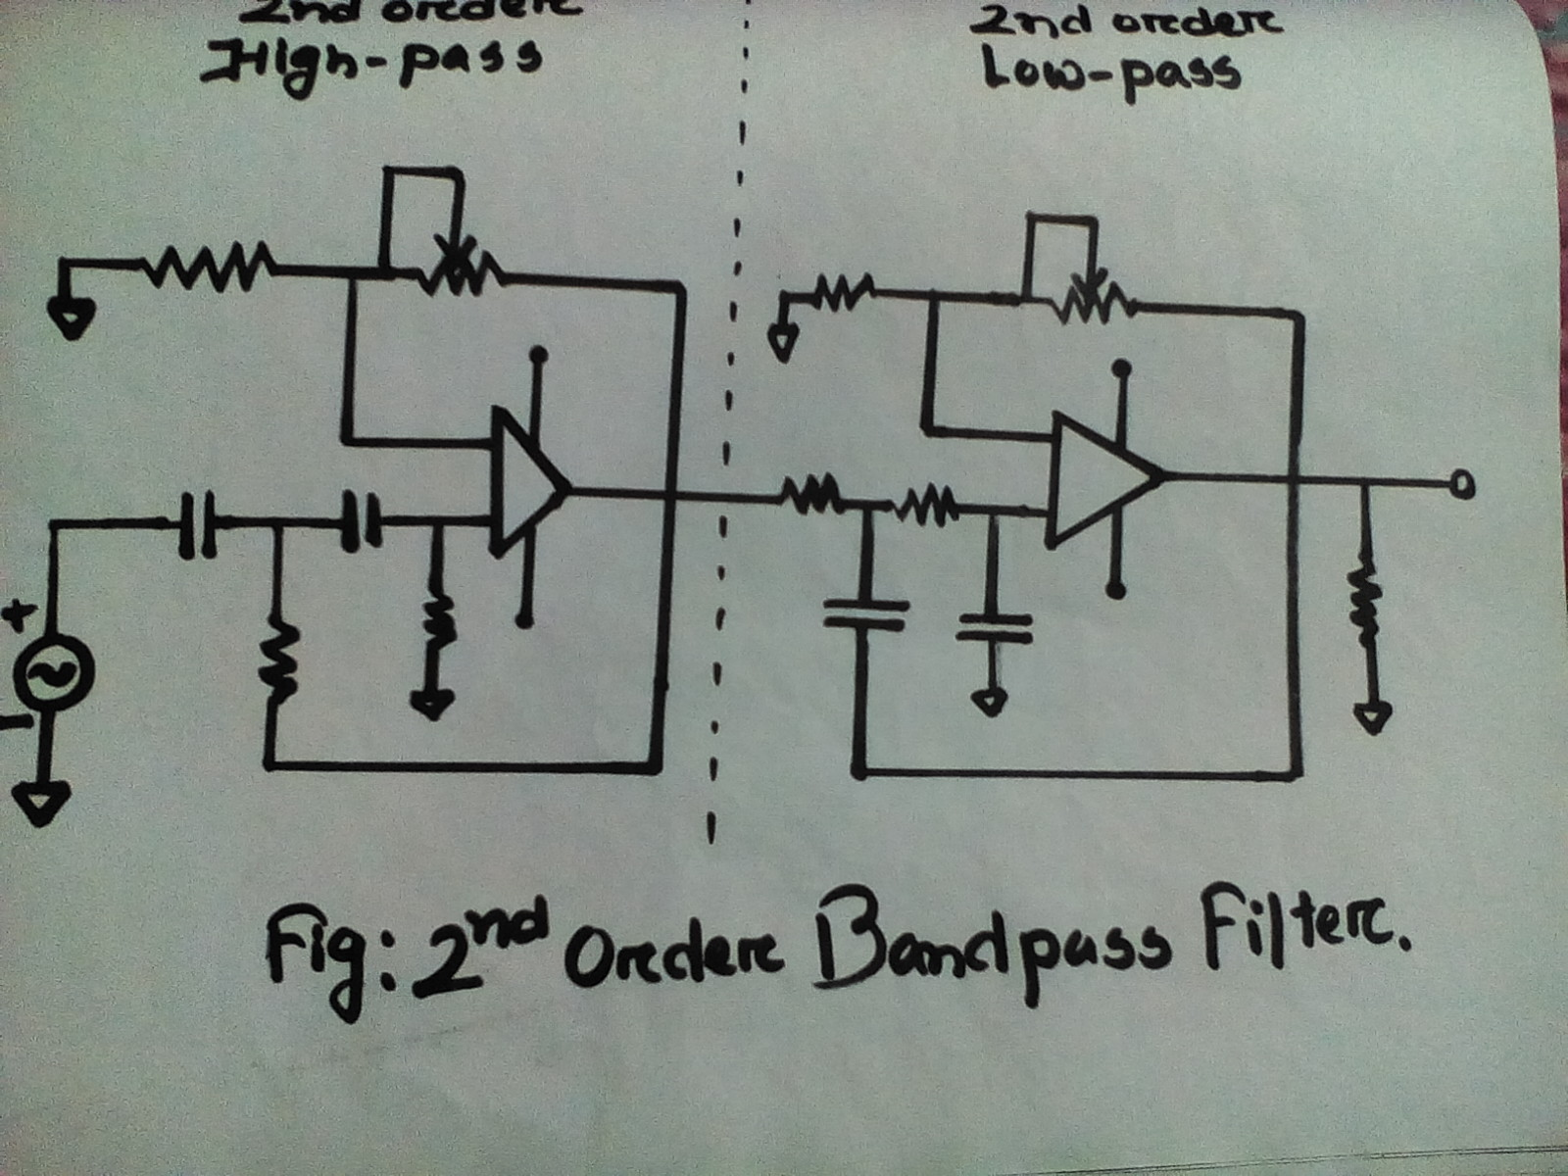

6.EXPERIMENTAL DATA:

|  |  |  |  |
| --- | --- | --- | --- |
| FREQUENCY  (kHz) | INPUT VOLTAGE(VI) | OUTPUT VOLTAGE(V0) | GAIN |
| 1.0 | 6.2 | 7.56 | 1.21 |
| 2.0 | 4.0 | 11.18 | 2.8 |
| 3.0 | 3.2 | 12.60 | 3.9 |
| 4.0 | 2.6 | 12.20 | 4.7 |
| 5.0 | 2.5 | 11.42 | 4.6 |
| 6.0 | 2.52 | 10.59 | 4.2 |
| 7.0 | 2.57 | 9.78 | 3.8 |
| 8.0 | 3.08 | 8.92 | 2.9 |
| 9.0 | 5.2 | 8.17 | 1.6 |
| 10.0 | 5.3 | 7.40 | 1.4 |
| 11.0 | 5.1 | 6.68 | 1.3 |
| 12.0 | 4.9 | 5.91 | 1.24 |
| 13.0 | 4.6 | 5.72 | 1.2 |

RF=10kΩ

R1=10kΩ

Calculated gain=(1+10/10)*10/10=2

Calculated cut-off frequency=3.98kHz to 10.61kHz

Measured cut-off frequency=4kHz to 9kHz

GRAPHICAL ANALYSIS:

COST ANALYSIS:

|  |  |  |  |  |
| --- | --- | --- | --- | --- |
| SL.NO | Apparatus name | Rating | Quantity | Price(Tk) |
| 1 | Op-amp | LM-741 | 2 | 30 Tk |
| 2 | Resistors | 1K,2K,10K Ω | 9 | 4.5 Tk |
| 3 | Capacitors | 0.01 µF, 0.04 µF | 4 | 8 Tk |
| 4 | Others | - | - | 30 Tk |
|  |  |  |  | TOTAL: 72.5 Tk |

DISCUSSION:

In this experiment,we acquired knowledge about bandpass filter and it’s frequency response.We set our calculated cut-off frequencies at 4kHz and 10kHz.But due to some instrumental error we got the frequencies at nearly 4kHz and 9kHz.We measured input and output voltages for several frequencies.We plotted a graph of Gain Vs Frequency. First the output voltage was increasing but at a particular level the output voltage was almost constant.After sometimes it was decreasing.Though there were some errors the experiment was overall successful.

Applications:

* In wireless transmitters and receivers
* In neuroscience, visual cortical simple cells
* In the atmospheric sciences
* Signal-to-noise ratio

CONCLUSION:

Through this experiment, we observe the frequency response of a 2nd order bandpassfilter.We measured the gainand plotted graph.We could build the circuit with less expenses.Our experiment was successful.

REFERENCES:

1.OP-AMPS and Linear Integrated Circuits(by RAMAKANT A.GAYAKWARD)